Draft: Multi-Disciplinary Death Review 2012-2021
Abstract
Objectives
Methods
Results
Conclusions
Background
While child deaths are incredibly regretful, they are also widely preventable. Explaining why health equity is in many ways connected to child deaths can unveil new opportunities to promote prevention strategies to the community. Death certificate data cannot thoroughly explain a child death and further, neither can information from a multidisciplinary death review team. We looked to unearth a more complex explanation to the child deaths in El Dorado County over 10 years that can help support measures in child death prevention strategies.
Introduction
The mortality rates among children in the United States have noticeably increased over the last decade (Concerning Trends in U.S. Teen Death Rates | KIDS COUNT Data Center, n.d.). According to Woolfe et al., child mortality rates in ages ranging between 0 to 19, rose 20% from 2019 to 2021, citing a large increase in mortality. Overtime the leading causes of death have changed from deaths by disease (pneumonia, tuberculosis, and diarrhea) to deaths by unintentional injury (accidents, etc.), natural, and intentional injury, based on changes in prevention and advancements in science, deaths in disease improved (Cunningham et al., 2018). Regardless of these changes, health inequities continue to be factored in the reasons for death occurrences (Perry et al., 2019). The research on child mortality is derived from death certificate data from the Centers for Disease Control and Prevention (CDC).
Although advancements in halting certain causes of death among children have increased, health inequities among children have been staggering (Perry et al., 2019). Examples of this look like increase in the mental health crisis, deaths involving firearms, and increases in suicide rates as well (Woolf et al., 2023). Discussing and understanding the aspect surrounding the idea of health equity is essential when public health professionals and their teams decide on prevention strategies to combat child mortality (Victoria et al., 2003 & Hoyer et al., 2022). This process is essential and is supported by child death review teams (CDRT) and the various specialty lenses (coroner’s office, office of education, child protective services, etc.) contributing the overview of a child’s death. In the United States most states partake in some form of CDRT, whether they are required to report annually, this is essential to the overall reporting of childhood deaths across the nation (Quinton, 2017). In addition, child mortality may also have a correlation to generational inequities, and thus can explain reasons for certain demographics of children who die and why they more impacted and susceptible to early deaths (Hoyer et al., 2022). With that, adverse childhood events are also impactful due to the nature of these experiences associated with long-term negative effects and trends of early childhood deaths (Finkelhor, 2020).
Child death reviews are the multidisciplinary review of individual child deaths to help communities understand why children die and equip them to effectively prevent future fatalities (NCFRP, 2022). CDRT’s have two main purposes, they are tasked in identifying and collecting data regarding the cause and manner or child deaths, and in providing prevention strategies to state or local agencies based on data collected (Quinton, 2017). Teams carry a huge burden regarding child death reviews because their recommendations have immeasurable impacts for mortality rates among children, and the influence there is on initiatives that reduce these rates (Webster et al., 2003). Child death reviews in public health have been some of the main sources of preventing child deaths through public policies that increase in safety and child protection and health promotion (Ornstein et al., 2013). A collective action is needed for positive outcomes regarding injury prevention and risky behaviors among child deaths to thereby close gaps within communities who experience high incidences of child deaths (Victora et al., 2003). This can be accomplished by also including an equity focus during these overviews.
Health equity can be defined as the opportunity in achieving one’s full health potential regardless of one’s social position (CDC, 2022). Considering that health inequities are also connected to adverse childhood events, points to the damage these experiences have to one’s health and wellbeing (Finkelhor, 2020; Lensch et al., 2020). The assessment of health inequities among children have been shown to measure the disparities in school attendance, mental health difficulties, and depression among the several measurements related to equity metrics (Anderson & Zimmerman, 2021). Additionally, defining the parameters of what health equity is and the interactions between mortality rates among children can highlight guidelines in advancing health equity (Montoya-Williams et al., 2020). Although health equity has been a recent phenomenon recognized by public health, the remnants of these impacts have created a new category for why certain health issues occur, and the historical roots to such indifferences (Woolf, 2017).
El Dorado County is comprised of both rural areas throughout the county and apart of the Sacramento metropolitan area in the western most part of the county (welldorado.org). The very eastern area is the South Lake Tahoe region, where the demographics have a higher Hispanic population, whereas the rest of the county is mostly comprised of White population. El Dorado County has had a steady increase in population over the years as well as increases in diverse populations (uscensus). According to the U.S. Census Bureau, there was 7% increase in population from 2012 to 2021 in El Dorado County. As of 2021, 76% of the population was Non-Hispanic White, 13.7% were Hispanic, 5.7% were Asian, 0.8% were American Indian and Alaskan Native, 0.7% were Non-Hispanic Black, and overall, there were about 11.7% of the population that were two or more races. Children make up about 19% of the total population of El Dorado County, and from 2012 to 2021 there was 3.7% decrease in the population of children aged 0 to 19 years old.
Methods
We conducted a retrospective population-based study and looked at residential and non-residential deaths that occurred in El Dorado County among children 19 years of age and younger between the years 2012 and 2020. The definition of child deaths require familiarity with manners and causes of death (appendix A for manner of death) and other known risk factors that may have been a cause for a child’s death.
Data Sources
We used a combination of gathering child death data from the California Integrated Vital Records System (Cal-IVRS). We also utilized information gathering from partners within MDRT to further expand the scope of a child’s death from El Dorado County Sherriff’s office, El Dorado County Office of Education, Child Protective Services, El Dorado County Probation, El Dorado County Coroner’s office, and El Dorado County Public Health Agency. Case information is entered into our county’s central database for child deaths and used primarily from the counties public health agency for further analysis. Moe importantly we gathered identifiable data through birth and death certificates and those included were age, gender, race/ethnicity, zip code, county of residence, manner of death, and cause of death.
The deaths are categorized by accident, suicide, homicide, and natural manners of death with some cases that may still be pending and some that could not be determined. The county population was stratified by gender (male or female), age (<1, 1-4, 5-9, 10-14, 15-17, and 18-19), race and ethnicity (NH White, NH Black, NH American Indian/Alaskan Native, NH Asian, 2 or more races, Hispanic, and Unknown), resident or non-resident, and equity status (ranging from 1-5, 0 being those with more income equality and 5 those with more income inequality, while 0 for those out of county and not able to gather that information). The county population data was obtained using data from the US Census Bureau.
We used the health indicator of income inequality to measure the equality in the population of El Dorado County and whether this indicator has a correlation to the child deaths in the county from 2012 to 2020 (welldorado.org). It is well known that income inequality is strongly associated with an individual’s health status and socioeconomic status. To estimate each case to income inequality I used the county’s website that used the Gini coefficient to measure income inequality by zip code (welldorado.org). Also utilizing California’s Healthy Places Index (HPI) we can see that the county has an HPI score in 39.9th percentile, indicating that overall, the county is on the lesser side of a healthy community. The key strategies are to provide prevention to El Dorado County child deaths by looking to the equity measures and geographic regions that may influence a child’s death.
Measures
The study outcome was to observe the relationship there is between health equity and child deaths, while also looking at geographic residence per child. It is well known that equity is directly related to income inequality, and thus we used information gathered by our county’s partner with Conduent, who provides the county with health indicators, such as income inequality. The measure used to calculate income inequality was the Gini coefficient and was done for regions of the county and zip code. The range of the coefficient is between 0 and 1, where 0 indicates complete equality and 1 indicates complete inequality (welldorado.org). For the purposes of the study, the inequity has values between 1 and 5, where 1 means complete equity and 5 means complete inequity, due to variability over the 10 years of data. Twenty-seven of these deaths were out-of-county residents and the income inequality data could not be calculated. Additionally, El Dorado County’s website (welldorado.org) geographically locates health equity status of the county and has such information as far back as 2014 to the present, 2023 (welldorado). Using this tool allows us to expand our scope on El Dorado County child deaths and the needs of the community that may be impacted due to poor health equity.
Crude mortality rates were calculated per 100 000 people and were calculated using the U.S. Census demographic estimates for each year. These estimates were used for each year from 2012 to 2021 for the county of El Dorado. Rates were calculated for all causes and manner of death, by equity and income inequality. According to California’s Health places Index (HPI), El Dorado County has 39.9% healthier community conditions than other California tracts. The county has a very low equity status for the race/ethnicity diversity indicator with a value of 25.7% or an 8.8 percentile ranking among the state.
Results
Demographic Characteristics
From 2012 to 2021, there were 164 deaths among children 0 to 19 years of age in El Dorado County. /the child deaths comprised of 103 males and 61 females. Among age groups, the highest age group to experience deaths were infants <1 years old with 50 deaths, 43 deaths were
From 2012 to 2021, there were 164 deaths among children 0 to 19 years of age in El Dorado County. The child deaths comprised of 103 males (62.8%) and 61 females (37.2). Among age groups, the highest age group to experience death were infants <1 years old with 50 deaths (30.5%), 43 deaths were from the 18-19 age group (26.2%), 27 deaths were from the 15-17 age group (16.5%), 16 deaths were from the 1-4 age group (9.7%), and there were 14 deaths for both 5-9 and 10-14 age groups (8.5% each) (Table 1). The mean age group among the sample were 5–9-year-olds.
Table 1 denotes that deaths were more likely to occur among White individuals with 109 total deaths or 66.5%. This statistic may be due to the large population of White individuals who make up 83% of the total population of El Dorado County. Much of these manners of deaths are due to natural causes (48) and accidental deaths (35). There were 31 deaths from Hispanic/Latino’s, and of those deaths a majority were also due to accidents (12) and natural (11) manners of death. Overall, each race and ethnic group had more deaths among accidents and natural deaths according to the data from Cal-IVRS.
Table 1. Manners of Death occurring in El Dorado County by Age, Sex, and Race/Ethnicity, among those 0 to 19 years of age, 2012-2021

Characteristic | Accident | Natural | Suicide | Homicide | Could not be determined
Total Cases, n(%) | 55(33.5) | 73(44.5) | 21(12.8) | 5(3.0) | 7(4.3)
Age, n(%)
<1 | - | 44(60.3) | - | 1(20.0) | 5(71.4)
1-4 | 6(10.9) | 8(11.0) | - | - | -
5-9 | 6(10.9) | 7(9.6) | - | 1(20.0) | -
10-14 | 4(7.3) | 7(9.6) | 2(9.5) | - | 1(14.3)
15-17 | 12(21.8) | 4(5.5) | 11(52.4) | - | -
18-19 | 27(49.1) | 3(4.1) | 8(38.1) | 3(60.0) | 1(14.3)
Sex, n(%)
Female | 18(32.7) | 31(42.4) | 7(33.3) | 1(20.0) | 4(57.1)
Male | 37(62.2) | 42(57.5) | 14(66.7) | 4(80.0) | 3(42.8)
Race and Ethnicity, n(%)
Hispanic/Latino | 12(21.8) | 11(15.1) | 6(28.6) | 1(20.0) | -
American Indian/Alaskan Native | 2(3.6) | 1(1.4) | - | - | -
Asian | 3(5.5) | 3(4.1) | - | - | -
African American | 1(1.8) | 1(1.4) | - | 1(20.0) | -
Multi-Race | 2(3.6) | 8(11.0) | - | 1(20.0) | -
White | 35(63.6) | 48(65.8) | 15(71.4) | 2(40.0) | 7(100.0)
Unknown | - | 1(1.4) | - | - | -

Crude mortality rates were calculated per 100,000 people, and shown in Table 2,
Patterns of Income Inequality and Health Equity
Figure 1. shows the equity status over time within these years (2014, 2016, 2019, and 2021). Among these maps of El Dorado County, the dark blue can be seen decreasing as equity seems to be increasing among the geographic regions. However, there are still many communities that are experiencing greater needs especially those in the South Lake Tahoe area as well as the more rural areas of the county both North and South. This is commonly used to measure income inequality, where the coefficient is between 0 and 1, however for the purposes of this study, the range is between 1 and 5, where 1 means complete equality and 5 means complete inequality. The income equality status used zip code information in El Dorado County as a comparison and matched those values using the Gini coefficient formula. This information denotes where children likely fell within the range regarding income equality.

Trends

Figure 2. shows the rates of the manners of death among El Dorado County residents 0 to 19 years of age by year (2012-2021). Overtime, fluctuations occurred among all manners of death, as well as total deaths overall. Natural deaths persistently had the highest or higher rates compared to the other manners of death in El Dorado County. In 2020 there was a peak of 22 deaths over the 10-year review; these deaths in 2020 as well as 2021 are not related to COVID-19 pandemic. Of this manner of deaths, 73 were due to natural causes (44.5%), 55 were due to accidents (33.5), 21 were suicides (12.8%), 5 were homicides (3%), and 7 could not be determined (4.3%). Not included were pending deaths (3 total). Males were involved in approximately 57% of natural deaths during this study period and are at higher rates among other manners of death overall. The
Limitations
El Dorado County is a relatively small county compared to other counties in California, and thus there is smaller data sets to work with and can be seen in this study. The Health Equity index only goes back to 2014
Conclusion
It is the hope that El Dorado County’s MDRT can use the information they obtain regarding child deaths over this 10 year span, and use the knowledge regarding the community’s equity to really address child deaths with an impact.

Appendix
Appendix A: Manner of Death Definitions
Indicator | Definition
Manner of Death | Classification system developed for public health statistics based on the circumstances under which a death occurred (how the person died)
Accident | An unexpected of unforeseen death due to injury
Homicide | Death as a result of a volitional act committed by another person (e.g. injury, poisoning)
Natural | Death due solely to natural disease
Suicide | Death resulting from intentional self-inflicted act
Undetermined | Manner of death used when the information pointing to one manner of death is no more compelling than another

Figure 1. Equity Status of El Dorado County Maps from years 2014, 2016, 2019, and 2021.
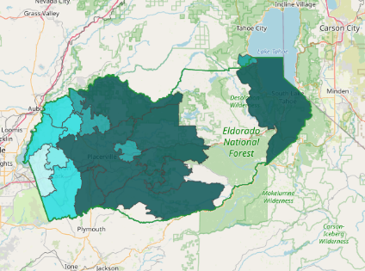  2014 | 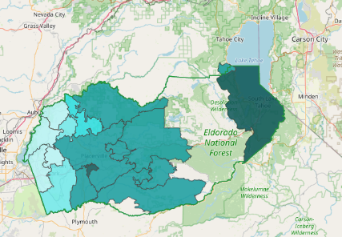  2016
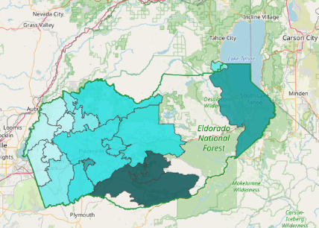  2019 | 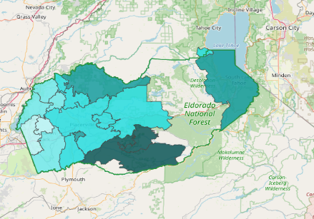  2021
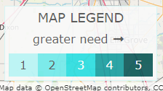
Seen in this equity map of El Dorado County, the darker the blue, the greater the need within that geographic area. This equity map utilizes zip codes to differentiate the needs among regions. (welldorado.org)

